DBMS

LAB ASSIGNMENT - 7



Ananya Agarwal

102083036

2CO14

Data:

create table SalesPeople

(Snum number primary key,

Sname varchar2(10) unique,

City varchar2(20),

Comm number(5,2) /float

);

insert into SalesPeople values(1001,'Peel','London',0.12);

insert into SalesPeople values(1002,'Serres','Sanjose',0.13);

insert into SalesPeople values(1004,'Motika','London',0.11);

insert into SalesPeople values(1007,'Rifkin','Barcelona',0.15);

insert into SalesPeople values(1003,'Axelrod','Newyork',0.10);

create table Customers

(Cnum number primary key,

Cname varchar2(10),

City varchar2(10) not null,

Snum number(5) references SalesPeople(Snum));

insert into Customers values(2001,'Hoffman','London',1001);

insert into Customers values(2002,'Giovanni','Rome',1003);

insert into Customers values(2003,'Liu','Sanjose',1002);

insert into Customers values(2004,'Grass','Berlin',1002);

insert into Customers values(2006,'Clemens','London',1001);

insert into Customers values(2008,'Cisneros','Sanjose',1007);

insert into Customers values(2007,'Pereira','Rome',1004);

create table Orders

(Onum number primary key,

Amt number(10,2),

Odate date,

Cnum number(5) references Customers(Cnum),

Snum number(5) references SalesPeople(Snum)

);

insert into Orders values(3001,18.69,to_date('3-10-1990','dd-mm-yyyy'),2008,1007);

insert into Orders values(3003,767.19,to_date('3-10-1990','dd-mm-yyyy'),2001,1001);

insert into Orders values(3002,1900.10,to_date('3-10-1990','dd-mm-yyyy'),2007,1004);

insert into Orders values(3005,5160.45,to_date('3-10-1990','dd-mm-yyyy'),2003,1002);

insert into Orders values(3006,1098.16,to_date('3-10-1990','dd-mm-yyyy'),2008,1007);

insert into Orders values(3009,1713.23,to_date('4-10-1990','dd-mm-yyyy'),2002,1003);

insert into Orders values(3007,75.75,to_date('4-10-1990','dd-mm-yyyy'),2004,1002);

insert into Orders values(3008,4273.00,to_date('5-10-1990','dd-mm-yyyy'),2006,1001);

insert into Orders values(3010,1309.95,to_date('6-10-1990','dd-mm-yyyy'),2004,1002);

insert into Orders values(3011,9891.88,to_date('6-10-1990','dd-mm-yyyy'),2006,1001);

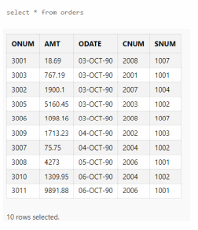

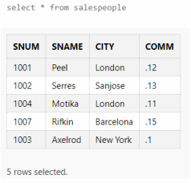

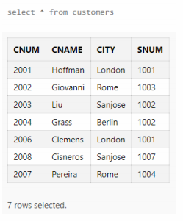

1. Count the number of Salesperson whose name begin with ‘a’/’A’.

select count(snum) from SalesPeople where lower(sname) like 'a%';



1. Display all the Salesperson whose all orders worth is more than Rs. 2000.

Note: Kyuki 1 salespeople ke 1 se zyada orders hosakte hai, thus have to grp by first and then add them and then compare with 2000.

select sname from salespeople where snum in (select snum from orders group by snum having sum(Amt) > 2000);

E:\4th sem\DBMS\lab\ass\My submissions\1.PNG

Method 2

select snum,sum(amt) from orders group by snum having sum(amt)>2000;

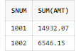

1. Count the number of Salesperson belonging to Newyork.

select count(snum) from SalesPeople where City = 'Newyork';



1. Display the number of Salespeople belonging to London or belonging to Paris.

select count(snum),City from SalesPeople where City in ('London', 'Paris') group by city;



1. Display the number of orders taken by each Salesperson and their date of orders.

Ques is: har salesperson ne uss date ko kitne order liye uska count chahiye.

select snum,odate,count(Onum) from orders group by snum,odate order by snum;

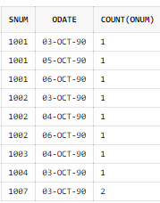

1. Write a query that counts the number of Salespeople registering orders for each day.

Uss din, kitne salesperson are taking the order.

select Odate,count(distinct(snum)) from Orders group by Odate;

distinct ke sath bracket need nahi hai yahan pr.

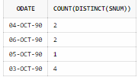

Acc to ques, order by need nahi hai, par ab ans ascedng order of date me aajyega bas itna frk hoga.

select odate,count(distinct snum) from orders group by odate order by odate;

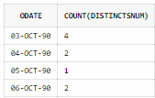

1. Write a query that selects the first customer in alphabetical order whose name begins with ‘G’.

Agar G se start hone vale bht saaare name hai, unmese sabse pehla cutomer kaun hai

select * from Customers where lower(Cname) like 'g%' order by Cname fetch first 1 rows only;

Method 2:

select * from customers where cname like 'G%' and rownum=1;

Method 3:

select min(cname) from Customers where lower(Cname) like 'g%';

E:\4th sem\DBMS\lab\ass\My submissions\1.PNG

1. Find out the largest orders for Snum 1002 & 1007.

select snum,max(amt) from orders where snum in (1002,1007) group by snum;

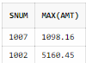

1. Find out the maximum single order amount (1 order ka amount) of a Salesperson over Rs. 3000 in a day.

select snum,odate,max(amt) from orders group by odate,snum having max(amt)>3000;

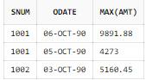

1. Find out the no. of Salesperson who belongs to same city and have same commission percentage.

select count(snum),city,Comm*100 "Commission Percentage" from Salespeople group by city, Comm*100;

select count(snum),city,Comm*100 "Commission Percentage" from Salespeople group by city, Comm*100 having count(snum) > 1;

ab display sirf vahi honge jo same hai thus unka count >1 hoga

